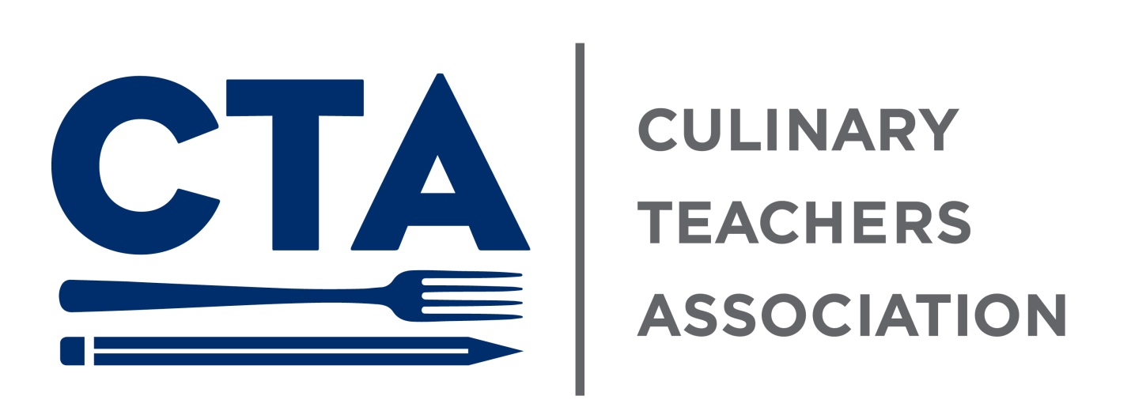

September 2020

**We’re Going Digital, Baby.**

After four years in print, the CTA newsletter is going digital. Although I love having a hard copy (I think I am the only person still getting home subscription to two newspapers.), a digital newsletter has several advantages including; no printing costs or wasted paper, and the ability to hyperlink pertinent information so it is easier for everyone to find.

This is my first run at putting together an email newsletter so if you have any suggestions on how to make it better, how to make it easier to use, or how to make it more visually appealing, please let me know. I’m hoping that using this format will make it easier to distribute both for me and for the area leaders that have helped get the newsletter out for the last few years. In the digital format we will be able to easily include retired members and other friends of the CTA to let them know about all our news. I have set up a new email account [thectanynewsletter@gmail.com](mailto:thectanynewsletter@gmail.com) to send and get submissions for the newsletter. The newsletter will be sent from the new email starting next month.

I hope you enjoy our new look and don’t be shy about letting me know what you think.

-Stephen

**Open Enrollment 2020**

It is almost time for our annual open enrollment. This year it is scheduled for September 14th to 25th. Kiley and Amanda in HR are setting up times reserved for CTA members to get help or answer questions. They are looking to meet through Teams and members can share their screen to have them walk you through the process. Take a look at your current benefits to see if they still fit you and your family or if you’d like to make some changes. Check out the various Benefit Guides [here](https://ciamainmenu.culinary.edu/employee-services/humanresources/Pages/BRC%20Pages/benefit-guides.aspx).

Monday, September 21st 11am to 1pm

Wednesday, September 23rd 2pm to 4pm

**VOTE!**

We are tentatively scheduled to host a voter registration drive on Wednesday September 30th. As we all know this election is super important and getting people to register is the first step. We are keeping a close eye on whether the state makes similar changes to voting like this spring’s primary elections where anyone was able to request an absentee ballot to vote by mail. Also in person early voting started in NYS last year and we will be publicizing times and locations for that. We will be looking to get some volunteers to help out. Contact Stephen at [seglinski@gmail.com](mailto:seglinski@gmail.com) if you are interested in helping.

**Summer Membership Meeting**

On Sunday August 23rd, we held a membership meeting and Kate presented the CTA’s annual financial report. We know Sunday meetings are difficult to attend but our bylaws require this report be delivered in August. It was also good to get an update from faculty that are currently teaching in person. If you have questions about the financial report, please contact Kate directly. There is also a recording of the Zoom meeting if anyone is interested in hearing it.

**Retirees**

In addition to all the upheaval the COVID 19 caused, we are also having a big year for faculty retirements. When we are allowed to get together in larger groups, we will look towards having a social event to help celebrate the many years of service to the institute and to the CTA that these faculty members have made. Join us in wishing **Jerry** **Fischetti**, **Carol** **Hawran, John** **Kowalski, Hubert Martini,** and **Kathy Polenz** well as they venture into a wonderful new phase in their lives.

**Legal Plan**

Through the CTA’s [group legal plan](https://memberbenefits.nysut.org/program-service/legal-and-financial/legal-service-plan) all our members gain access to a myriad of benefits. Every month we will try to spot light a different benefit.

* **Bankruptcy** – Plan attorneys can offer advice on alternatives such as creditor “workout” in situations of overwhelming debt, including suspension of interest, budget review and, in extreme circumstances, Chapter 7 and Chapter 13 bankruptcy alternatives. Where appropriate, the Plan attorney may contact the creditor involved to discuss favorable alternatives to ever-mounting debt or collection litigation

National Legal Office phone numbers

NYS (excluding Long Island)………………………… (800) 832-5182

After Hours Hotline ………………………………………. (800) 292-8063

**Know Your Contract**

Workload-Teaching Requirements for Faculty

Article VIII section 5 (p.7)

Note: Because this is a big section in the CBA, it will be covered over several Know Your Contract sections.

1. Overview

All CIA faculty members are expected to contribute on a yearly basis in all three areas that traditionally define the workload for faculty in academic institutions: teaching, intellectual contributions and service. These activities allow the institution both to create and disseminate knowledge and to serve the needs of the institutions, the profession and society at large.

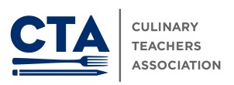

Richard Horvath, President c (845) 224-5283

Stephen Eglinski, Vice President c (845) 464-5864

Kate Cavotti, Treasurer c (845) 489-1353

Michael Nothnagel, Secretary o (845) 905-4782